 | Year 12 Methods  Week 5 Quiz | $$\frac{}{16}$$

Name: __________________
1. | Find the derivative of $f(x)=\sqrt{4x^{2}-3}$. | 2
2. | Find the antiderivative:  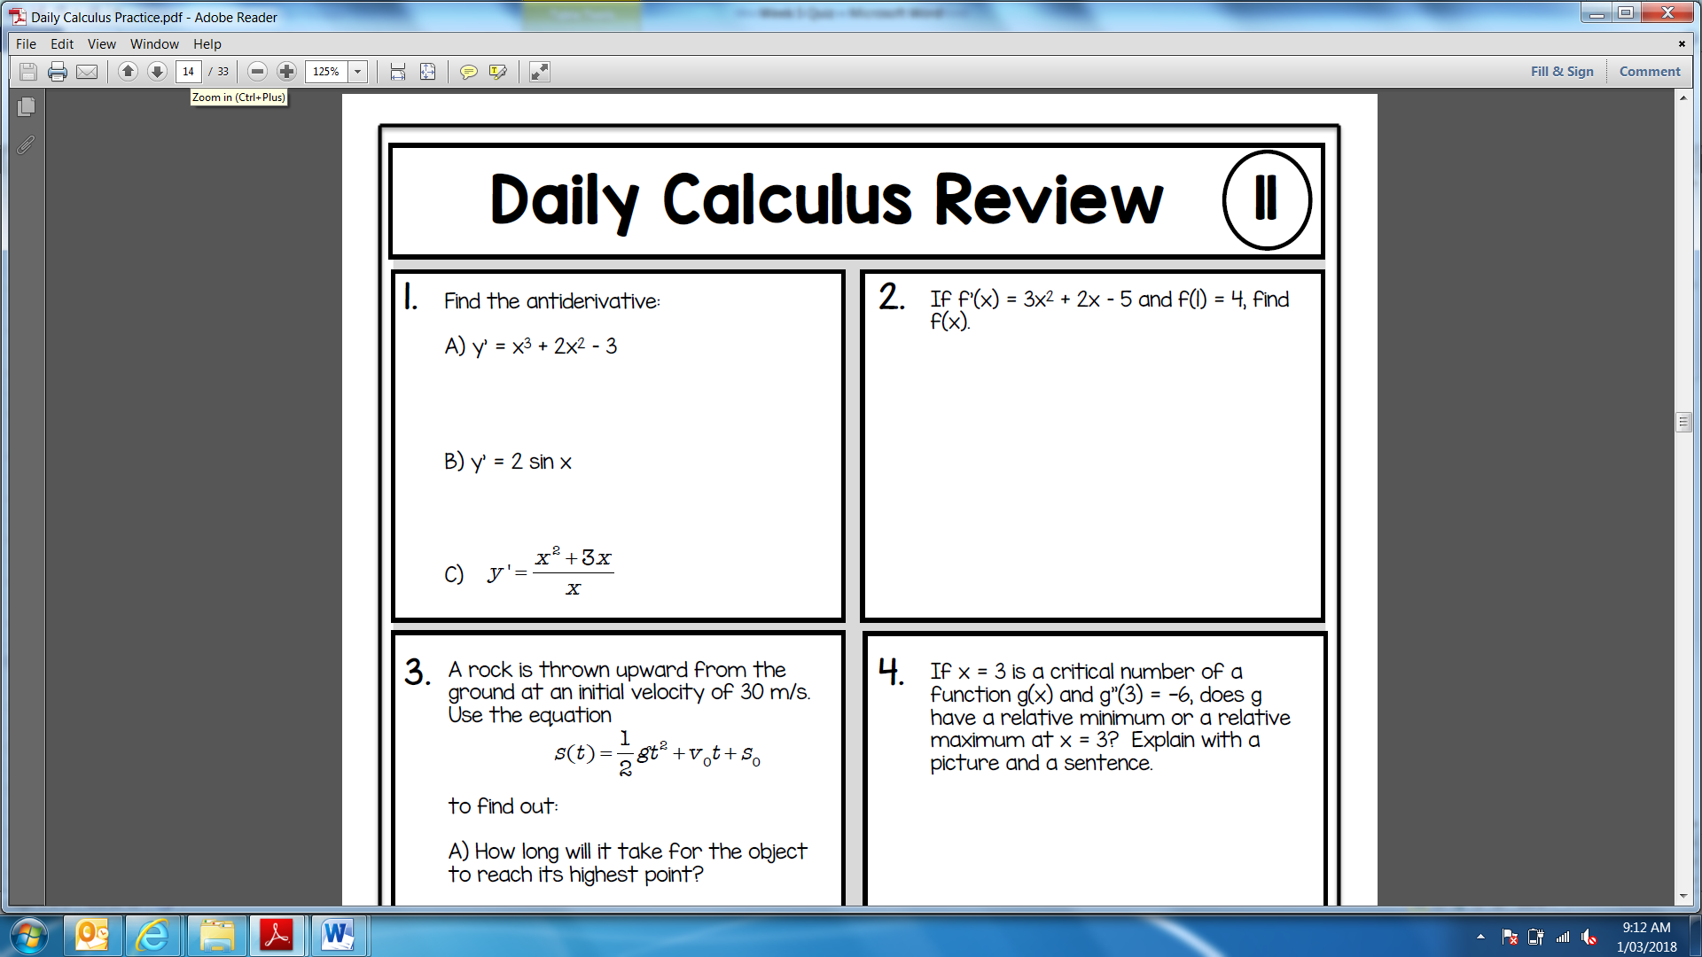 | 2
3. | Find the antiderivative:   | 1
4. | Consider the function $y=x^{2}+2.$ Use the right end-point method to find an approximation to the area between the curve and the x-axis over the interval [0,2]. Use 4 rectangles.  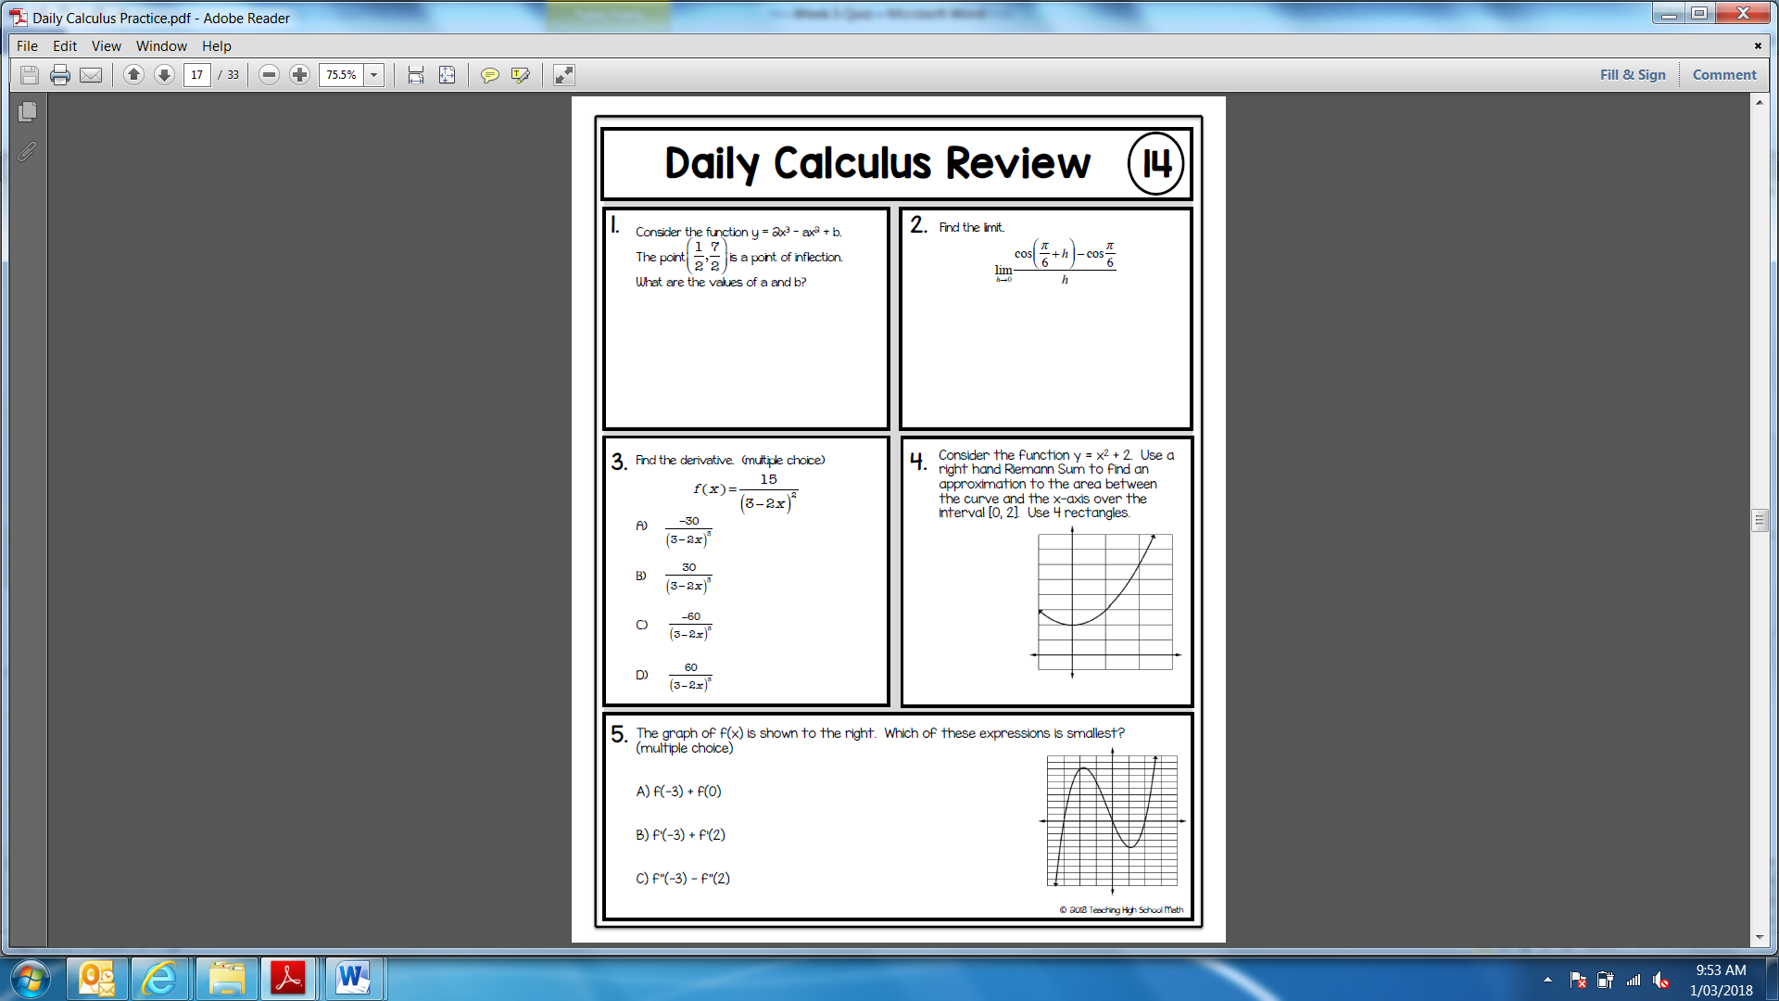 | 3
5. | Find:  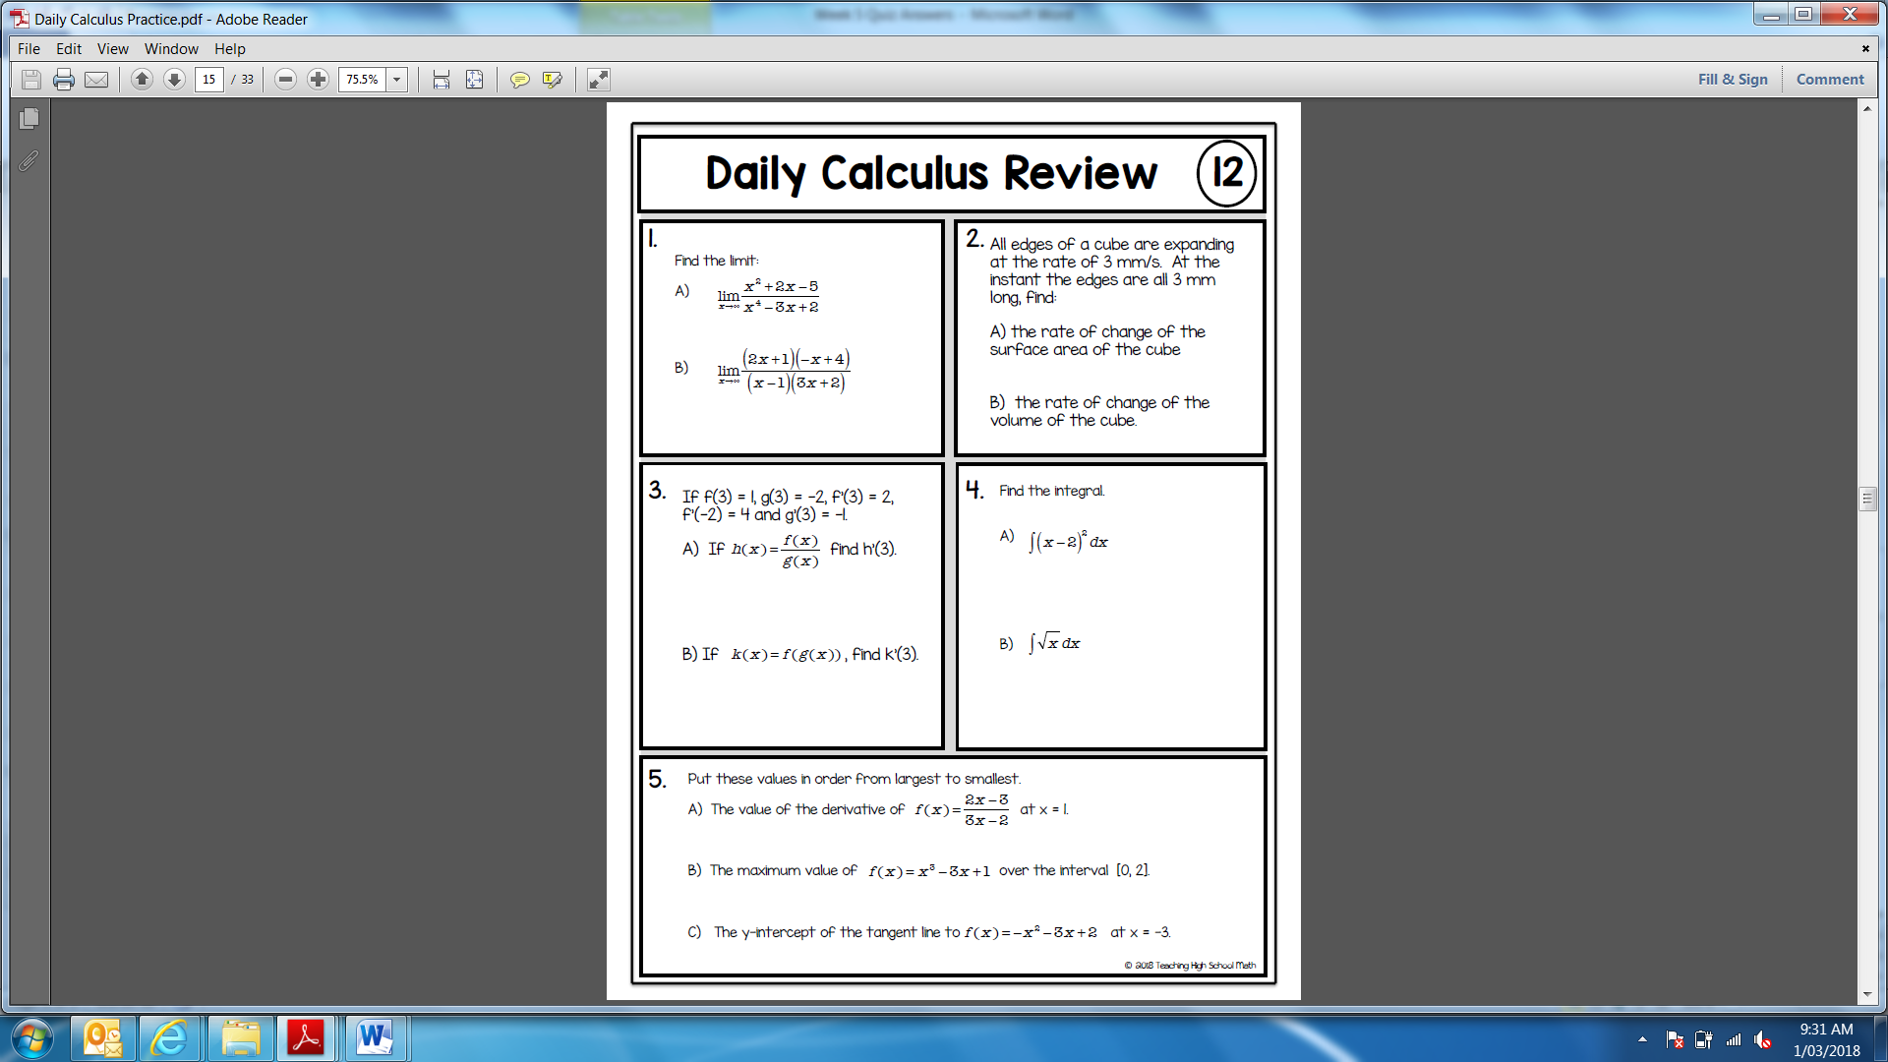 | 2
6. | Find:   | 2
7. | Find:  $$\int{\frac{2}{(3x+1)}dx}$$ | 2
8. | Find:  $$\int{\frac{1}{(4x-1)}dx, x<\frac{1}{4}}$$ | 2

